

Theme Parks- Dashboard
Ramandeep Kaur

Table of content
- Introduction 2
  - Objectives of BI Dashboards 2
  - Benefits/Advantages of BI Dashboards 2
  - Assumptions 2
  - Description of business rules and of variables used in this report 3
- BI Dashboards 4
  - Dashboard 1: For Campaign Manager 4
Chart 1 4
Chart 2 5
Chart 3, 4, 5… and commentary of each chart 5
  - Dashboard 2: For HR 6
Chart 1, 2, 3… and commentary of each chart 6
  - Dashboard 3: For Individual User 7
Chart 1, 2, 3, 4, 5… and commentary of each chart 7
- Recommendations 8
- Reference 8
- Appendix 9

- Introduction

In today's digital landscape, phishing attacks pose significant threats to organizations, compromising data and undermining security efforts. This report addresses these challenges by presenting a comprehensive analysis through BI dashboards tailored for different stakeholders: Phishing Campaign Managers, HR Managers, and Individual Users.

Each dashboard is designed to offer valuable insights, enabling proactive measures to mitigate cyber risks. For
Phishing Campaign Managers, the dashboard facilitates tracking email engagement, evaluating payload effectiveness, and comparing industry trends, aiding in optimizing phishing campaign strategies.
HR Managers benefit from visualizations that assess communication effectiveness, training program impact, and geographic trends in phishing susceptibility, thereby enhancing overall cybersecurity readiness. (Keepnet, n.d.) Individual Users gain insights into demographic and geographic vulnerabilities, training efficacy, and phishing tactics, fostering data-driven decision-making to bolster cybersecurity defences. (Sophos, 2024)

The report underscores the importance of real-time threat awareness, targeted training programs, and resource allocation to strengthen organizational resilience against phishing attacks. By leveraging these dashboards, organizations can effectively monitor, evaluate, and enhance their cybersecurity posture, safeguarding sensitive data and ensuring robust protection against evolving cyber threats.

Objectives of BI Dashboards

    - Objective 2 (for Phishing Campaign Manager):

- Monitor Campaign Engagement: Track email engagement metrics such as email opens and link clicks over time to identify patterns and trends.
- Assess Data Compromise: Analyze instances of compromised data to understand the severity of cybersecurity threats and prioritize risk mitigation efforts.
- Evaluate Payload Types: Identify prevalent payload types used in phishing campaigns and assess their impact on data security and organizational risk. (Ironscales, n.d.)
- Compare Industry Trends: Compare compromise rates across different industries to identify sectors with higher susceptibility to cyber threats and potential areas for improvement.
- Assess Campaign Effectiveness: Evaluate the performance of individual phishing campaigns based on user engagement metrics to optimize resource allocation and improve campaign outcomes. (Siadati, Palka, & Siegel, 2024)

    - Objective 2 (for HR Manager):

- Evaluate Communication Effectiveness: Assess how well emails are being received and opened by employees across different departments.
- Identify Age-Related Vulnerabilities: Understand patterns in phishing link-clicking behavior across various age groups to tailor cybersecurity training accordingly.
- Analyze Geographic Trends: Identify locations with higher susceptibility to phishing attempts to focus cybersecurity awareness efforts.
- Assess Training Program Impact: Measure the effectiveness of cybersecurity training programs by analyzing average scores and completion rates.
- Improve Cybersecurity Readiness: Enhance the overall cybersecurity posture of the organization by identifying and addressing gaps in employee awareness and training. (Hustix, n.d.)

    - Objective 3 (for Individual User):

- Identify Vulnerable Groups: Highlighting demographic and geographic trends in phishing susceptibility to target specific groups for enhanced training.
- Evaluate Training Effectiveness: Assessing the correlation between phishing incident reporting and training completion to identify gaps in our cybersecurity strategy. (Lin, Capecci, & Rocha, 2019)
- Monitor Engagement: Tracking employee engagement with phishing emails across different income levels and departments to tailor future awareness campaigns.
- Analyze Phishing Tactics: Examining the effectiveness of different phishing strategies based on email sender and subject to improve detection and prevention efforts.

Benefits of BI Dashboards

    - Benefit 1 for Phishing Campaign Manager

- Enhanced Threat Awareness: Provides real-time visibility into phishing campaign engagement and data compromise, enabling proactive threat mitigation.
- Improved Risk Management: Facilitates the identification of high-risk areas and payload types as few payload types needs one to be more cautious as they have different ways of attacking, this allows organizations to implement targeted security measures specific to different payloads.
- Optimized Resource Allocation: Enables organizations to allocate resources efficiently by focusing on campaigns with the highest engagement rates and optimizing marketing ROI.
- Enhanced Campaign Performance: Helps identify successful campaign strategies that have been conducted and areas for improvement, leading to more effective communication and marketing efforts. This enables us to select the most useful campaign out of all 6 conducted. (Heather & Parker, 2020)

    - Benefit 2 for HR Manager

- Enhanced Targeting: The dashboard helps in identifying specific departments, age groups, and locations that require more focused cybersecurity training and awareness initiatives.
- Improved Communication: By understanding engagement levels across departments, the organization can tailor its communication strategies to ensure more effective dissemination of information.
- Increased Awareness: Visualizing phishing link-clicking behaviour helps in raising awareness about cyber threats and the importance of vigilant online behaviour.
- Better Training Outcomes: Insights into training performance highlight areas for improvement, leading to more comprehensive and effective training programs.
- Proactive Risk Management: Identifying gaps in cybersecurity readiness allows for proactive measures to mitigate risks and protect the organization from potential cyber-attacks.

    - Benefit 3 for Individual User Dashboard:

- Enhanced Decision-Making: The dashboard provides actionable insights to inform targeted cybersecurity training and awareness programs.
- Risk Mitigation: It identifies high-risk groups and regions, enabling proactive measures to reduce susceptibility to phishing attacks.
- Resource Allocation: It further helps allocate resources efficiently by focusing on the most vulnerable employees and regions.
- Improved Awareness: Increases overall cybersecurity awareness among employees by highlighting the prevalence and impact of phishing attacks.
- Data-Driven Strategy: Facilitates a data-driven approach to developing and implementing cybersecurity policies and practices.

Assumptions
The findings and analyses identified by the dashboard are derived from an amalgamation of publicly available data sources identified in Table x.
Assumptions for Campaign Manager Dataset
Assumption 1: Each phishing campaign has a unique identifier that helps in distinguishing it from others.

Assumption 2: The content of the email body will always contain a [Malicious link] or [Malicious attachment], indicating the presence of harmful elements intended to deceive the recipient.

Assumption 3: The type of malicious payload used in the phishing campaign, such as Malware or Credential Harvesting. This categorizes the main method of attack.

Assumption 4: The start and end dates of campaigns do not show a clear pattern but suggest continuous phishing efforts across different months.

Assumptions for Human Resources Dataset
Assumption 1: It is assumed that the employees who haven’t completed the training have failed the training thus scoring less than 50% based on other aspects.

Assumption 2: Each employee has an associated IP address, potentially indicating their primary working location or device.
Assumption 3: Employees hired more recently might have lower salaries compared to those hired earlier, assuming salary increments over time.
Assumption 4: Each employee has an associated IP address, potentially indicating their primary working location or device.

Assumptions for individual User Dataset
Assumption 1: Income levels are categorized into High, Medium, and Low, which might be based on predefined salary ranges within the company or industry standards.

Assumption 2: "Data Entered" implies that consumers might enter sensitive information, which is a critical metric for understanding the risk and impact of phishing attacks.

Assumption 3: Phishing email subjects and senders vary widely, suggesting an attempt to simulate different types of phishing attacks that a consumer might encounter.

Assumption 4: The dataset includes the subject and sender of phishing emails to analyse which types of phishing attempts are more successful.

Assumption 5: The dataset includes both trained and untrained consumers, which allows for the analysis of training trends across different demographics.

  - Description of business rules and variables used in this report

Campaign Manager Dataset

Attribute | Data Type | Description | Business Rule
Campaign Name | String | Name of the phishing campaign | Non-nullable, unique, and descriptive of the campaign
Target Industry | String | Industry sector targeted by the campaign | Non-nullable, valid industry name
Target Region | String | Geographical region targeted by the campaign | Non-nullable, valid region name
Email Subject | String | Subject line used in the phishing email | Non-nullable
Email Body | String | Content of the phishing email | Nullable
Attachment | String | Name of the file attached to the email | Nullable
Landing Page URL | String | URL of the landing page used in the campaign | Non-nullable, must be a valid URL format
Payload Type | String | Type of malicious payload used (e.g., Malware, Credential Harvesting) | Non-nullable, valid payload type
Payload Details | String | The particular malware or credential harvesting technique used in the payload | - TrojanBanker.MSIL - This is designed to steal banking credentials.  - TrojanDownloader - Downloads and installs other malware once executed on the victim's machine.  - TrojanSpy - Monitors the victim's activities and steal sensitive data.  - Phishing Page - Indicates the payload directs victims to a fake website crafted to harvest login credentials.
Launch Date | Date | Start date of the phishing campaign | Non-nullable, must be a valid date
End Date | Date | End date of the phishing campaign | Non-nullable, must be a valid date, should be after Launch Date
Emails Sent | Integer | Number of emails sent during the campaign | Non-nullable, non-negative
Emails Opened | Integer | Number of emails opened by recipients in that specific campaign | Non-nullable, non-negative, cannot exceed Emails Sent
Clicks | Integer | Number of clicks on the malicious links in the campaign | Non-nullable, non-negative, cannot exceed Emails Opened
Compromised | Integer | Number of successful compromises in the particular campaign | Non-nullable, non-negative, cannot exceed Clicks

HR Manager Dataset

Attribute | Data Type | Description | Business Rule
Transaction ID | String | Unique ID that identifies each transaction | Unique value, Not nullable
Employee ID | String | Unique ID that identifies each employee | Unique value, Not nullable
First Name | String | First name of the employee | Not nullable
Last Name | String | Last name of the employee | Not nullable
Email Address | String | Work email address of the employee | Unique value, Not nullable
Department | String | Department where the employee works | Not nullable
Job Title | String | Job title of the employee | Not nullable
Hire Date | Date | Date when the employee was hired | Not nullable
Salary | Integer | Annual salary of the employee | Positive value, Not nullable
Age | Integer | Age of the employee | Positive value, Not nullable
Gender | String | Gender of the employee | Acceptable values: Male, Female, Non-binary, Not nullable
Location | String | Work location of the employee | Not nullable
Phone Number | String | Contact phone number of the employee | Must be a valid phone number format
IP Address | String | IP address of the employee's device | Must be a valid IP address format
Email Opened | Boolean | Indicates if the employee opened the email | Acceptable values: Yes, No
Link Clicked | Boolean | Indicates if the employee clicked a link in the email | Acceptable values: Yes, No
Training Completed | Boolean | Indicates if the employee completed training | Acceptable values: Yes, No
Average Score | Percentage | Average score of the employee in training | Not nullable

Individual User Dataset

Attribute | Data Type | Description | Business Rule
Transaction ID | String | Unique ID that identifies each transaction | Unique value; Not nullable
Consumer ID | String | Unique ID that identifies each consumer | Unique value; Not nullable
First Name | String | First name of the consumer | Not nullable
Last Name | String | Last name of the consumer | Not nullable
Email Address | String | Email address of the consumer | Must be a valid email format; Not nullable
Age | String | Age range of the consumer | Must be one of the predefined age ranges
Gender | String | Gender of the consumer | Not nullable
Location | String | Location of the consumer | Not nullable
Income Level | String | Income level of the consumer | Must be one of the predefined income levels
Phishing Email Subject | String | Subject line of the phishing email received by the consumer | Not nullable
Phishing Email Sender | String | Email address of the sender of the phishing email | Must be a valid email format; Not nullable
Link Clicked? | String | Indicates if the consumer clicked on a link in the phishing email | Not nullable
Attachment Opened? | String | Indicates if the consumer opened an attachment in the phishing email | Not nullable
Data Entered? | String | Indicates if the consumer entered data after clicking a phishing link | Not nullable
Reported Phish? | String | Indicates if the consumer reported the phishing email | Not nullable
Training Status | String | Training status of the consumer in phishing awareness | Not nullable

BI Dashboards

Dashboard For Phishing Campaign Manager

The Phishing Campaign Insights Dashboard presents a holistic view of email engagement metrics and data compromise incidents across our organization's simulated phishing campaigns which involved different departments and how prone the employees are to phishing attacks in that department. Furthermore, an overall evaluation of the phishing campaign conducted over the period of 4 months was executed in the dashboard.
Through intuitive visualizations, the dashboard illuminates campaign performance, user interactions, and payload characteristics. By offering valuable insights into cybersecurity risks, the dashboard enables proactive strategies to be formulated, thereby enhancing the organization's defence against phishing attacks and safeguarding its sensitive data.

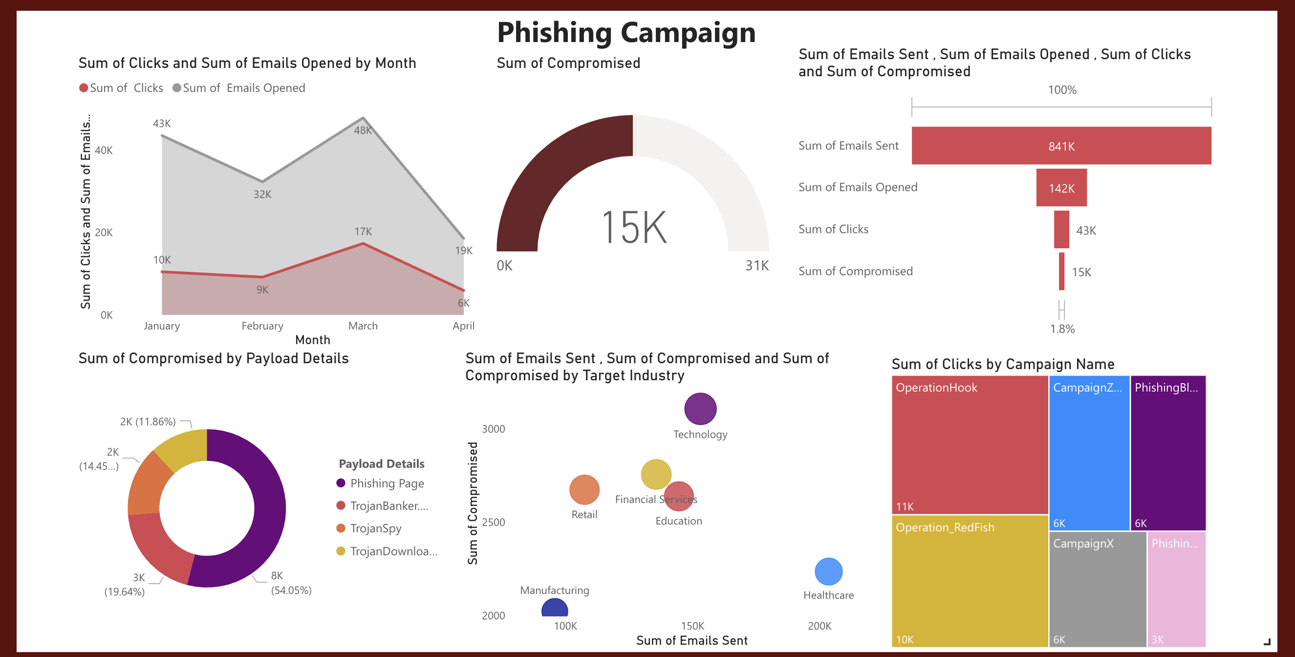
Campaign Manager Dashboard

Chart 1

A thorough analysis of the phishing campaign data presented by area chart which was beneficial in revealing a distinct pattern in email engagement over the first four months of 2024. In January, the campaigns saw a total of 43,000 emails opened and 10,000 links clicked. This level of engagement declined slightly in February, with 9,000 links clicked. However, March experienced a significant spike in activity, recording 17,000 links clicked, indicating a heightened response to the phishing attempts during this month. By April, the engagement decreased substantially, with only 6,000 links were clicked. This trend highlights a peak in phishing engagement in March, followed by a notable drop in April. a

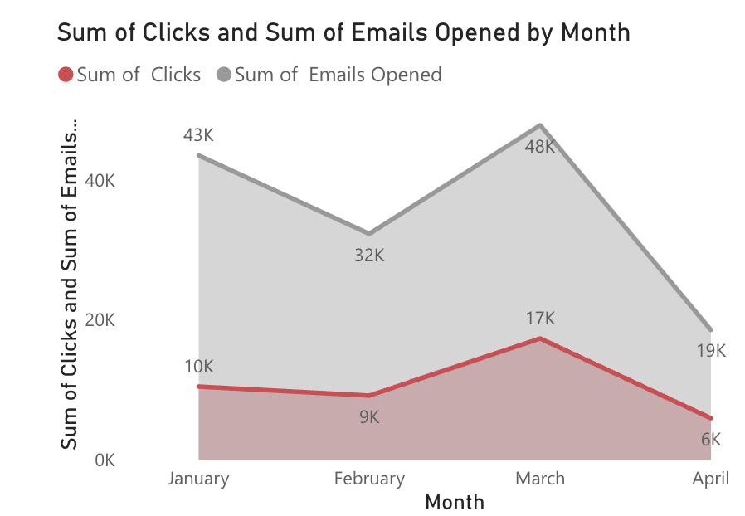
Figure 1 Sum of emails sent and phishing links clicked on them

Chart 2
The phishing campaigns conducted depicts that a total of 15K times the data was compromised out of the 841K emails sent to conduct the campaigns. This emphasizes the urgency to strengthen the cybersecurity measures. There is a critical need for proactive steps in enhancing email security protocols, thereby mitigating the risk of data breaches and safeguarding organizational assets.
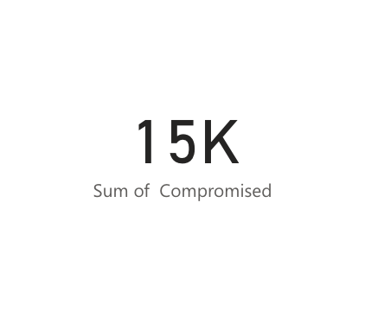
Figure 2 The sum of times the data was compromised.

Chart 3

The funnel chart encapsulates the journey of email engagement and its impact on data security. With a sum of 841,000 emails sent as the initial pool, 142,000 emails were opened, indicating a notable level of engagement. Subsequently, 43,000 clicks were registered, reflecting further user interest and interaction with the email content. However, the most critical insight emerges from the final stage, where it is revealed that 15,000 instances of compromised data occurred.

This highlights how dangerous cyber threats are, even when many people initially open the emails. The chart helps in depicting serious warning about needing strong email security to prevent data breaches and protect organizations.

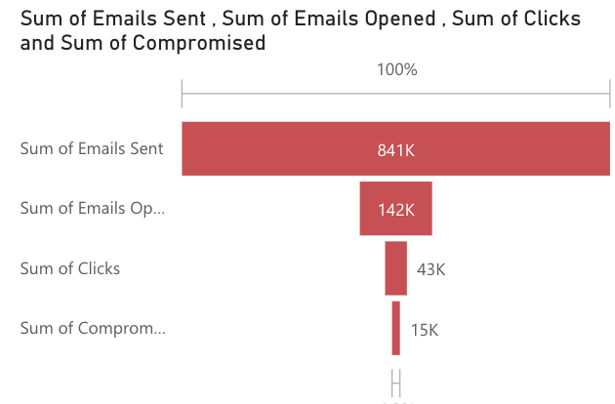
Figure 3 Funnel chart depicting the stages of campaigns

Chart 4

Among the identified payload details, phishing pages constitute the largest proportion as depicted by donut chart, accounting for 54.05% of compromised data. This payload type signifies a grave concern as it directs victims to fraudulent websites aimed at harvesting sensitive login credentials. Trojan Banker payload, comprised 19.64% of compromised data which poses a significant risk by targeting banking credentials. Additionally, Trojan Spy and Trojan Downloader payloads contribute 14.45% and 11.86% respectively to the compromised data landscape. Trojan Spy monitors user activities and steals data, while Trojan Downloader installs other malicious software, posing a threat to sensitive information.

The donut chart visually highlights the distribution of compromised data among different payload types, aiding in the identification of predominant threats and their respective proportions.

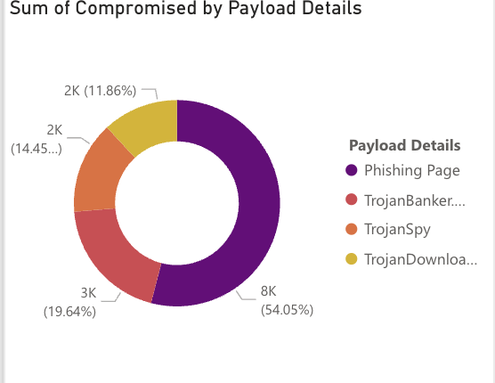
Figure 4: Donut chart representing compromised in each campaign conducted.

Chart 5

The scatter plot is beneficial in illustrating how different industries face varying levels of compromise in cybersecurity. Despite manufacturing sending fewer emails, it experienced relatively fewer compromises, while sectors like retail and financial services saw higher compromise rates despite sending out similar or fewer emails. Surprisingly, healthcare, with the highest email volume, encountered a lower number of compromises suggesting that the sector may have stronger cybersecurity defences or practices in place compared to other industries. This could include robust email filtering systems, regular employee training on cybersecurity best practices, or advanced threat detection mechanisms in the healthcare sector.

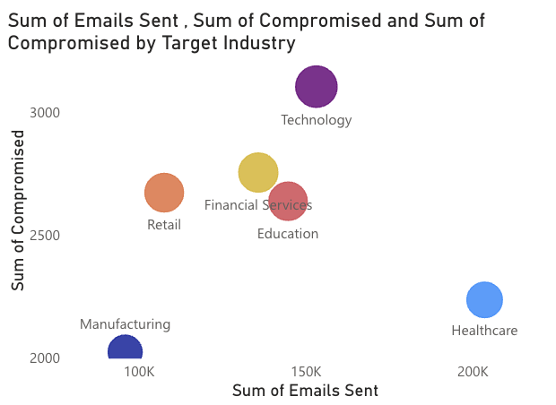
Figure 4: Scatter chart for compromised data over different industries

Chart 6

Our tree map represented that among all the campaigns, OperationHook stands out with the highest number of clicks at 11,000, closely followed by Operation_RedFish with 10,000 clicks. This provides insights into the effectiveness of each campaign in engaging recipients and driving interaction which further helps in identifying successful strategies and areas for improvement in their marketing or communication efforts. Additionally, it helps in allocating resources more efficiently by focusing on campaigns that yield the highest engagement rates, ultimately optimizing marketing ROI and achieving campaign objectives more effectively.

Our tree map allows in easy identification of successful strategies and areas for improvement.

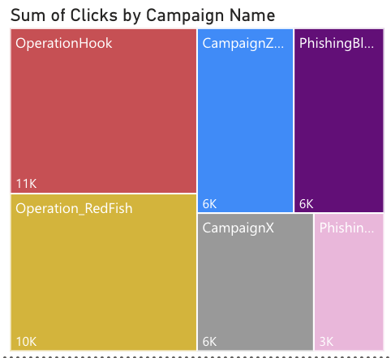
Figure 5: Tree map for clicks occurred in each campaign.

  - Dashboard for HR Manager

The primary goal of the Human Resources Dashboard is designed to provide a comprehensive overview of various employee metrics, enabling the organization to assess and improve its communication strategies, cybersecurity awareness, and overall workforce engagement. The dashboard visualizes key data points such as email engagement, age-related susceptibility to phishing attempts, geographic trends in cybersecurity behaviour, and the effectiveness of training programs. Through these insights, the dashboard aims to enhance our understanding of employee behaviours and inform targeted interventions to strengthen our organizational defences against cyber threats.

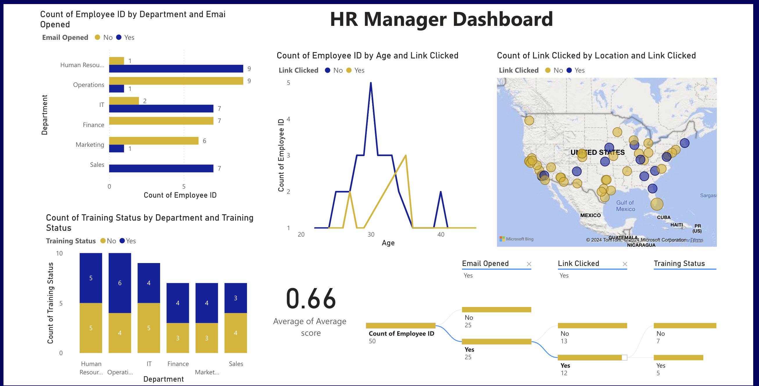
Figure 6 Dashboard for HR Manager

Chart 1

In exploring the effectiveness of our communication strategies, we utilized a clustered bar chart to assess email engagement across different departments within the company. The objective was to gain insights into how effectively our emails are being received and opened by employees in various departments. The findings revealed notable differences in email open rates among departments. Human resources and sales departments showed high levels of engagement, with most emails opened signifying that they are more prone to cyber-attacks, the finance department exhibited no email opens at all. The bar chart easily depicts variations in emails across different departments.
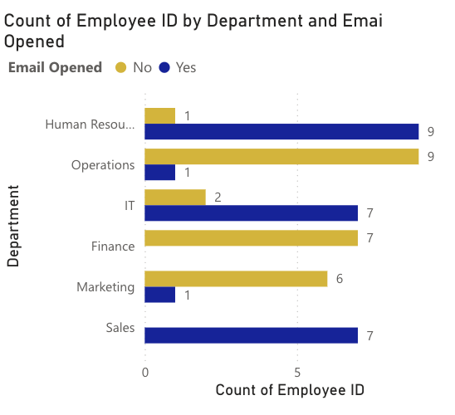
Figure 7: Clustered bar chart depicting emails opened in each department.

Chart 2

The relationship between employees' ages and their interaction with potentially malicious links in emails has been depicted through a line chart, we aimed to discern any patterns or trends in link-clicking behavior across different age groups. The findings revealed interesting insights into age-related susceptibility to phishing attempts. Employees in their mid-30s emerged as particularly susceptible, with all individuals in this age bracket clicking the links provided. This observation suggests that individuals in this age range may not be as familiar with cyber threats and therefore more prone to falling victim to phishing attacks. Conversely, younger and older age groups showed more varied responses, with some clicking the links while others did not.

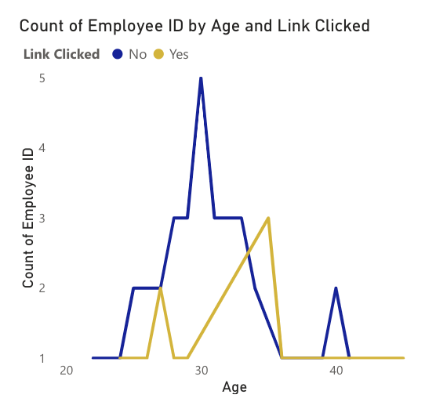
Figure 8: Line chart for links clicked across different ages

Chart 3

Our analysis also extended to geographical trends in employee susceptibility to phishing attempts, using a map visualization to illustrate link-clicking behaviour across various locations. Notably, locations such as Los Angeles, New Mexico, Kansas, Nebraska, Chicago, Washington, Florida, and Boston had employees who clicked the links. This geographic distribution highlights areas where cybersecurity awareness may be lower and suggests a need for more focused cybersecurity training in these regions.
Conversely, employees in other locations exhibited better caution, indicating varying levels of awareness and vigilance against phishing attacks. The map is helpful in depicting areas where people are most prone to cyberattacks.

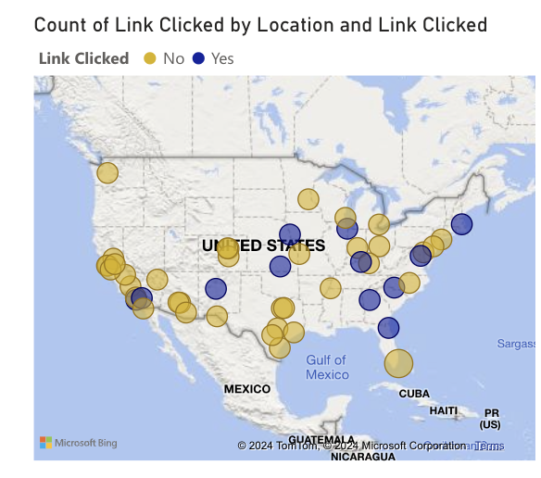
Figure 9: Map depicting links clicked in different localities.

Chart 4

We analysed the average scores achieved by employees, which were visualized to reflect overall performance. The objective was to understand the effectiveness of the training and identify areas needing improvement. The analysis showed an average score of 66%, with a notable range from 23% to 99%. Some employees did not complete the training, resulting in scores below the passing threshold of 50%. These findings highlight inconsistencies in training completion and comprehension, emphasizing the need for more effective and comprehensive training initiatives.

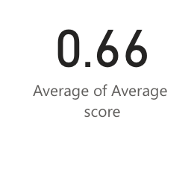
Figure 10: Average training score

Chart 5

A decomposition tree to analyse key metrics from a sample of 50 employees was made which provides a comprehensive breakdown of key metrics, identifying critical areas for improvement in their cybersecurity awareness program. The objective was to gain insights into email interactions, phishing link clicks, and training completion rates. The findings revealed that half of the employees opened the email, with 12 clicking the phishing link, and only 5 completing the training, while 7 did not. These observations highlight critical areas for improvement in our cybersecurity awareness program. The data shows many employees have not completed cybersecurity training, leaving us at risk of phishing attacks and data breaches.

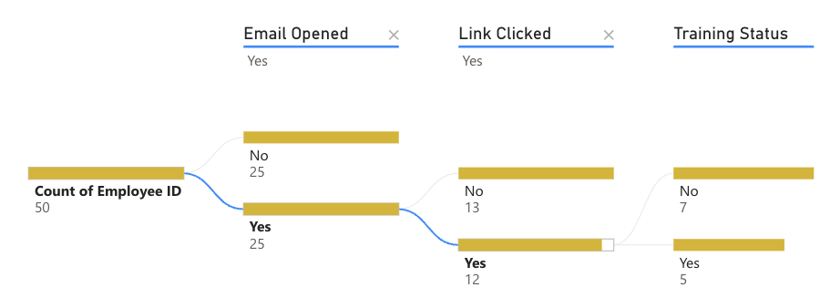

Figure 11: Decomposition tree for employee engagement and training
  - Dashboard for Individual User

While the goal of the dashboard is to offer a comprehensive link between individual behaviours and cybersecurity vulnerabilities, it also provides an insightful view of the current state of cybersecurity awareness and threats. The dashboard leverages various visualizations to present an overview of phishing activities and responses among employees, highlighting areas of concern and success in our cybersecurity initiatives.
These visualizations further showcase the success of our cybersecurity initiatives where employees exhibit vigilant behaviours. By dissecting these trends, the dashboard enables us to identify vulnerable groups, assess the effectiveness of our training programs.

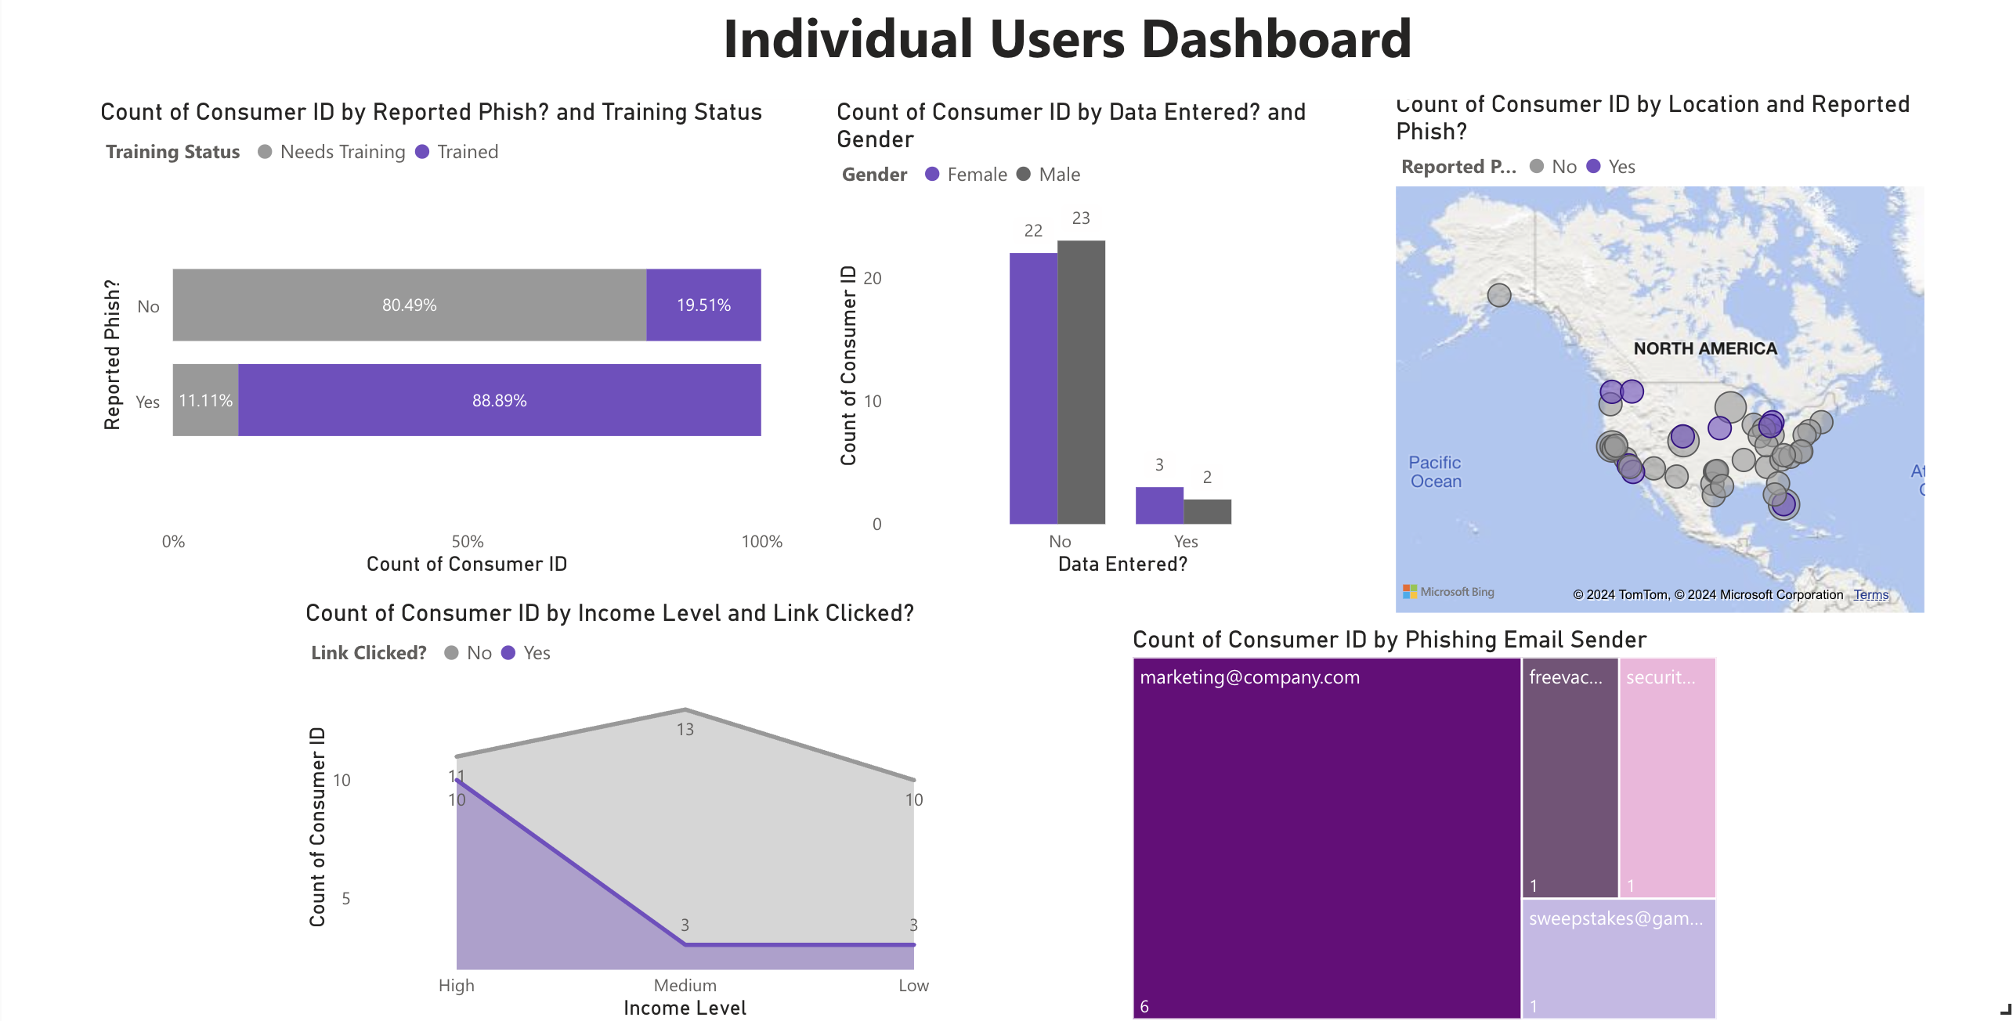
Figure 12: Individual User Dashboard

Chart 1

Our examination of cybersecurity training effectiveness revealed compelling insights through a 100% stacked bar chart which has an ability to clearly illustrate the correlation between phishing incident reporting and training completion, highlighting areas where our defence strategy may have gaps. Notably, around 90% of employees reporting phishing incidents completed their cybersecurity training, showcasing a strong correlation between incident reporting and training completion. Conversely, a mere 11.11% of employees reporting phishing incidents failed to complete training. In contrast, among employees not reporting phishing incidents, only 20% completed training, with a significant 80% failing to do so, potentially leaving gaps in our defence strategy.

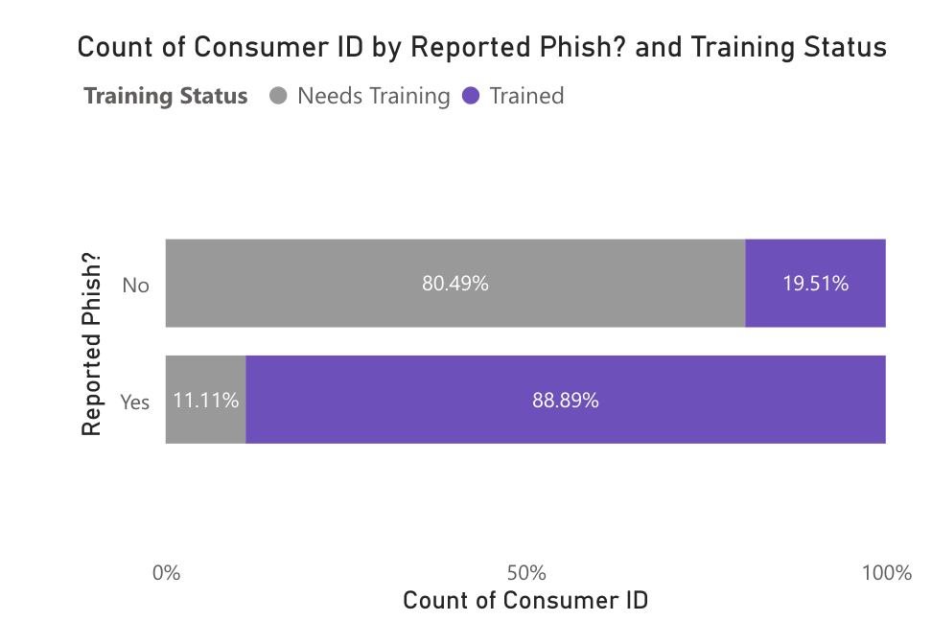
Figure 13: 100% stacked bar chart for phish reported.

Chart 2

The observed gender differences using a clustered column chart presents gender composition in response to the phishing campaign. This chart helps in highlighting potential disparities in cybersecurity awareness and engagement within our organization. The fact that a larger number of females and males refrained from entering data after encountering the phishing link suggests a concerning lack of proactive response to potential threats. Conversely, the small proportion of females and males who actively engaged by entering their data underscores the importance of targeted cybersecurity training and awareness initiatives. It's vital to recognize that the absence of data entry does not guarantee protection against cyber threats.

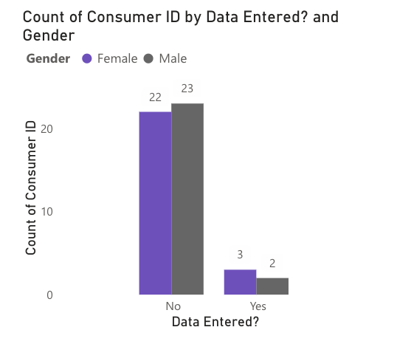
Figure 14: Clustered column chart for gender composition of data entered.

Chart 3

Our investigation into the geographic patterns using a map of phishing incident reporting gave a clear depiction of where these incidents occurred. Notably, reports originated from locations such as Washington, California, Denver (Colorado), Nebraska, Michigan, Ohio, and Florida. Employees in these regions may be more susceptible to phishing attempts, suggesting potential gaps in cybersecurity awareness and training.
Conversely, other areas had better vigilance against such threats signifying that they were less prone to falling for the phishing attacks and were aware of cyber-attacks and how to deal with them.
The map provides a clear understanding of where these incidents are concentrated and where cybersecurity awareness may need to be strengthened.

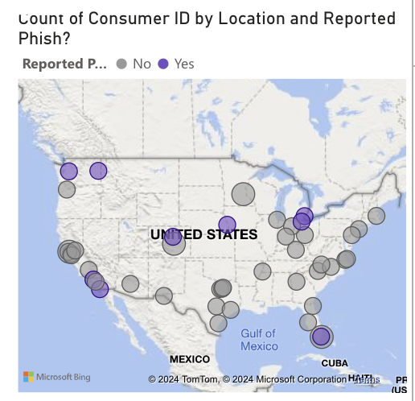
Figure 15: Map depicting phish reported across different locations.

Chart 4

Using an area chart we have presented phishing links clicked across different income levels. Different income levels offer valuable insights into the impact of cyber-attacks within our organization. Notably, high-income employees experienced a higher number of clicks on phishing links compared to other income brackets, they also had more significant amounts of sensitive data at risk. With 10 employees clicking the link and potentially compromising crucial information, the high-income group emerges as a prime target for cyber attackers. Conversely, the lower-income group, with fewer clicks on phishing links, still requires vigilant cybersecurity practices to safeguard against potential breaches. The benefit of using the area chart lies in its ability to visually represent the distribution of phishing link clicks across different income levels, allowing for easy comparison and identification of trends. This depicts we need the high-income level employees are more engaged in phishing mails sent and needs to be trained.

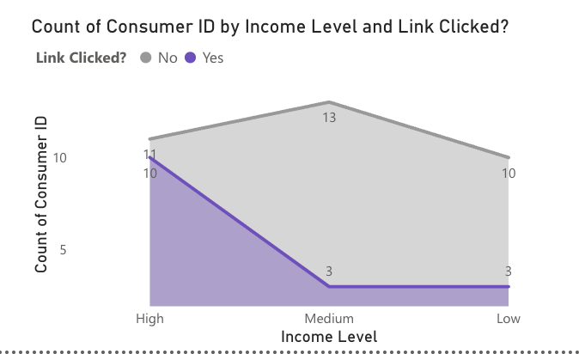
Figure 15: Area chart for links clicked across different income level

Chart 5

Our tree map visualization of phishing reports by email sender highlights the varying effectiveness of different phishing strategies. The marketing@company sender was reported the most at 6 times, indicating a higher frequency of detection, whereas senders like sweepstakes, free vacation, and security were reported only once each. This visualization helps us identify which phishing tactics are more easily recognized by employees, guiding our focus for future cybersecurity training and awareness efforts.

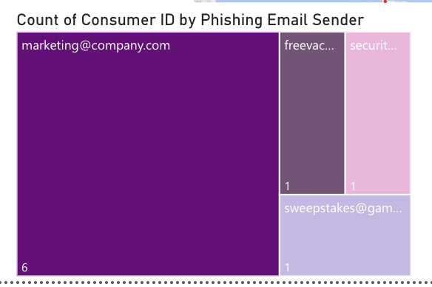
Figure 16: Tree map for phish reported.

Recommendations

Campaign Manager Dashboard

- Deploy advanced email filters to block phishing emails effectively and enforce Multi-Factor Authentication (MFA) for all employees to heighten security. (Okta, 2024)

- Simplify incident reporting with an intuitive system and conduct routine drills for swift response to phishing attacks.

- Establish real-time monitoring to detect spikes in phishing activity, enabling prompt action.

- Implement tailored security measures for high-risk payload types such as phishing page and launch focused awareness campaigns.

- Regularly analyse successful phishing campaigns to glean insights for future strategies and tactic

HR Manager Dashboard

- There is a need to implement tailored training modules for departments, age groups, and locations to address specific cybersecurity needs effectively and providing regular refresher courses to ensure ongoing skill development among employees.

- Conduct awareness campaigns via email, workshops, and online platforms to educate employees on evolving cyber threats. Use diverse communication channels to reach all employees and reinforce best practices.

- We can continuously analyse data to evaluate the effectiveness of communication and training strategies in improving cybersecurity awareness and resilience.

- Promote proactive cybersecurity practices, recognize employees adhering to standards with incentives, and encourage a culture of collective responsibility for safeguarding assets. (Patidar, 2024)

Individual User Dashboard

- Develop tailored cybersecurity awareness programs for different genders to bridge the gap in proactive responses and enhance overall vigilance against phishing threats.’

- Conduct in-person or virtual cybersecurity training sessions in areas with high reporting rates, ensuring employees in these locations are well-equipped to recognize and handle phishing attempts.

- Establish dedicated support teams in regions identified as more susceptible to phishing attacks, providing immediate assistance and resources to reinforce cybersecurity practices.

- Utilize insights from the income level analysis to focus cybersecurity efforts on high-income employees, who are more likely to be targeted by phishing attacks, ensuring they receive adequate training and resources.

Reference

Sophos. (2024). Dashboard. Retrieved from https://docs.sophos.com/central/customer/help/en-us/ManageYourProducts/PhishThreat/PTDashboard/index.html

Keepnet. (n.d.). Phishing Campaign Manager. Retrieved from https://doc.keepnetlabs.com/next-generation-product/platform/phishing-simulator/phishing-campaign-manager

Siadati, H., Palka, & Siegel. (2024). Measuring the Effectiveness of Embedded Phishing Exercises. Retrieved from unisemix: https://www.usenix.org/system/files/conference/cset17/cset17-paper-siadatti.pdf

Ironscales. (n.d.). Phishing Attack Simulation. Retrieved from 2023
Hustix. (n.d.). How to Measure the Effectiveness of Security Awareness Training. Retrieved from https://www.hutsix.io/how-to-measure-the-effectiveness-of-security-awareness-training

Lin, Capecci, & Rocha. (2019). Susceptibility to Spear-Phishing Emails: Effects of Internet User Demographics and Email Content. ACM transactions on computer-human interaction : a publication of the Association for Computing, 32.
Hesther. (n.d.).

Heather, & Parker. (2020). Contributing factors to increased susceptibility to social media phishing attacks. South African Journal of Information Management, 178-189.

Okta. (2024). Step up your game with Adaptive MFA. Retrieved from https://www.okta.com/au/products/adaptive-multi-factor-authentication/

Patidar, A. (2024). Enhancing Security: Leveraging 5 Real-Time Techniques to Detect Phishing Attacks . Retrieved from Loginradius: https://www.loginradius.com/blog/identity/real-time-techniques-detect-phishing-attacks/

Appendix (Certificate of Completion for Power BI & Datasets)

Campaign Manager Dataset
HR Manager Dataset
Individual User Dataset

